
Addis Ababa science and technology university
Smart Dorm System

GROUP 94 MEMBERS ID

- DAGMAWI ESAYAS ETS0204/12
- FATIMA ABAYNEH ETS0286/12
- IBRAHIM KEDIR ETS0364/12
- BODANA FIKIRU ETS0182/12
- EZANA DAGMAWI ETS0284/12
- YORDANOS GETACHEW ETS0728/12

Project Advisor: Dr. Kula Kakeba
February 10, 2023

Abstract
The goal of this project were to build a modern , easy-to-use , smart dorm system that allows for accessible and adds convenience ,utility and security to your own home (Dorm). It allows users to open their door remotely via accessible card designed in bracelet. The system is made up of three major components, including a cloud back-end, an on-board logical unit, and a mobile application.

Acknowledgments
we thank our IETP advisor Doctor kula kakeba for guiding
us throughout the project, and for his great flexibility on
agreeing to make this project an actual MQP.
Executive Summary
The goal of this project was to provide an easy and convenient method for unlocking a front door by removing the need for the old-fashioned key. We start by evaluating the need for such a system by sending a survey and analyzing the results. We follow the software development life cycle to set the project objectives and implement the design. The project has three main major components: an Arduino , a cloud back-end and a mobile application. The Arduino is attached to the door and is responsible to controlling a servo motor and an actuator. Users can open the door by either tapping a button on the mobile app, or just by approaching the door but for now we will take the later.
The smart lock app is the forefront of the system an intuitive user interface. From this app, you can opt in for a push notification that will let you know whenever someone at the door. Furthermore administrators can keep track the numbers of student that are using this system and specially to let them know who is absents in order to justify the cost sharing price.
Our project integrates a board computer like the Arduino, a Cloud back-end provided by Microsoft’s Azure, and a mobile application built in Swift. These three components come together to create a seamless and convenient way for you and your friends to control the doors of your home. Now you don’t have to worry about losing your key, getting locked out, or having your hands full with groceries, because the Smart Dorm system has you covered.

Table of Contents

1. INTRODUCTION 6
1.1. Background of study and motivation 6
2. PROJECT OBJECTIVE 6
2.1. Specific Objectives 6
3. A BRIEF OUTLINE OF THE REPORT 7
4. PROBLEM STATEMENT 7
5. SCOPE OF STUDY 7
5.1. Scope 7
5.2. Limitations 8
6. LITRATURE REVIEW 8
6.1. Fingerprint locking system 8
6.2. Knock-Pattern Using Arduino and GSM Communication 9
6.3. Key less Entry System Based on Arduino Board with Wi-Fi Technology 9
6.4. RF-ID Based Access Control System 9
7. METHODOLOGY AND MODELING 9
7.1. Software development life cycle 10
7.2. Requirement Gathering 10
7.3. Survey 10
7.4. Working Principle 11
7.5. Important Components 12
8. ENGINEERING ANALYSIS 15
8.1. Electrical circuit design and implementation 15
Four step includes 18
8.2. Dorm Modeling 20
9. PROJECT PLANNING 23
Table 1 23
10. RESULT & ANALYSIS 24
11. BUSINESS & ECONOMIC ANALYSIS 25
Table 2 25
11.1. Business Analysis: 26
11.2. Economic Analysis: 27
CONCLUSION 28
RECOMENDATION 29
REFERENCE 30

INTRODUCTION

Background of study and motivation
In our daily lives, safety is a major concern. Every person requires a sense of safety. Our security pattern includes an access control system for doors. Traditional locks are no longer as secure as they once were; anyone can gain access by breaking these locks. We need to create a system that will assist 24 hours a day, seven days a week. Only authorized individuals have access to restricted areas thanks to a password-based door lock system. Arduino is in charge of the entire system. A remotely accessible card can be used to enter the door . The door opens if the card matches the data entered in Arduino. This remotely-based smart structure will provide clients with a more secure and low-effort locking-opening mechanism. Mechanical door locks will be replaced by electronic door locks in the future, thanks to the security door lock automation system.

PROJECT OBJECTIVE
The goal of this project is to research and analyze a suitable collection of components for developing a smart door lock and dorm system using Arduino that provides excellent security and quick access. The general objective of our project is to create a smart dorm system for our IETP course. We want to work on the sector of higher education system and security system along with helping the poor people by making the cost more cheap.
The following are the specific project goals:
- Familiarity with a smart door locking system based on a micro-controller.
- Using Arduino to create a simple and smart door locking system.
- To design the dorm structure.
- Integrating Arduino with specific sensors.

Specific Objectives
- to design the dorm structure
- to design the lock and key system’s.
- to connect the sensor to the lock
- to check the suitability of the surrounding
- to create the bracelet
- to connect sensors to the home structural model
- when someone that unknown to the system gets near alert
- to make the house react to the the sound sensor by creating light from LED
- to regulate its temperature to optimal other than that alert

A BRIEF OUTLINE OF THE REPORT
This project is divided into 5 chapters. Chapter 1 present the background of study and motivation of this project. Chapter one also presents objectives and a brief outline. Chapter 2 provides the literature review of this project. Chapter 3 introduces the project methodology and modeling like working principle, process of work, component,implementation, testing and cost analysis. Chapter 4 presents the results and discussions of this project, also the simulation and experimental results. Finally, Chapter 5 Conclude the project.

PROBLEM STATEMENT
In today's world one of the difficulties so many people face is worrying. Worrying about their safety,material,job it will go on & on. The best outcome will be made by people who got no worries. So what we are trying to do in this project is shifting the priority more to the work rather than the false creation. This project purpose is to develop a smart dorm system that can be controlled remotely. It will be possible to reduce the error and time that can be taken by the users. This makes the customers enjoy the process so that its feasible technically,operationally,schedule and finally legally.

SCOPE OF STUDY

Scope
The reach of this project will include attribute that are net positive for the general time,
security and human management as they decrease carelessness and cost management that will paid if customers property stolen. This proposed solution offers well innovative way to help student and other sectors in security and safety issues. To furthermore clarify, everything which needs to be accomplished in this project are creating a fully functioning prototype.

Limitations
providing a high quality education, work system and enhanced with well customized security system requires time and unity in the work force. In the team there will be always a limitation to mention the pace,compatibility and flexibility. In the technology part there are some parts that we wont use because the budget and the knowledge we have right now.

LITRATURE REVIEW
There are just a few digital approaches for door security locks in the current system. This contemporary smart locking system takes the place of the classic lock and key locking method. Modern living is largely reliant on technological advancements, such as opening doors, managing the air conditioning, and regulating the curtains. People want to feel safe in their own homes, offices, and stores. The primary motivation for the development of smart locks is to meet the needs of people. Some of these systems will be discussed in this section.

Fingerprint locking system
A fingerprint locking system is a locking system that uses a fingerprint sensor module to secure the user's fingerprint. The fingerprint sensor module uses an Arduino or a Raspberry Pi to operate. In the proposed system, there is three-level security. Any two levels of security users have to face to unlock the system. This is the ideal option for avoiding the hassles of a stolen or lost key or illegal access. The authorized user must register his or her fingerprint in the system. The registered person's mobile number is then added to GSM, and a permanent image password is assigned to this user. As a first step, the unauthorized individual must choose unauthorized as the user type. The admin receives a random picture. The person must properly choose the random image. Otherwise, the system will go back to the first page.

Knock-Pattern Using Arduino and GSM Communication
This system, which consists of Arduino, GSM Module, Servo Motor, and other components, employs a ‘Secret Knocking Pattern' that is only known by the owner of the safe, luggage, or other property or item on which the device is mounted. For the lock to open, the knocking pattern must be used only at a certain location, which is only known by the owner. The secret pattern can only be changed after the secret knock has been unlocked. Because there is no key to be copied, this approach fully eliminates the worry of duplication.

Key less Entry System Based on Arduino Board with Wi-Fi Technology
A key-less entry system that focuses on the use of an Arduino circuit board, a Wi-Fi module, and the PHP programming language to provide access to a closed door. The suggested solution, which uses an Arduino Uno board and a Wi-Fi shield to unlock the door without a key, is described. The internet connection allows the system to unlock the door from any place, unlike traditional systems, which have a limited range.

RF-ID Based Access Control System
A magnetic door lock is administered through an RFID reader in the suggested system, which begins the authentication and validation of the user or regulates access in short. In addition, the systems keep track of each user's access and exit records in the form of a log report for each access. To avoid unforeseen circumstances, the administrator of the central subsystem can terminate the validity of any user at any moment.

METHODOLOGY AND MODELING
In this project, we implemented a Remote-Based Security System Using Arduino & Access card. As thefts are increasing day by day security is becoming a major concern nowadays. So a digital card lock can secure our home or locker easily. It will open your door only when the right card is touched. Only authorized people are allowed access to the restricted sections due to a remote-based door lock mechanism. The Arduino is responsible for the entire project's operation.

Software development life cycle
SDLC is a strategy that is used to ensure that products that are developed, are optimized for their users, based on a set of requirements. It is a very common strategy in software development projects. SDLC involves several steps Requirements Gathering, Analysis, System Design, Object Design, Testing, and Implementation. Each step ensures that the developers are ready for the next one and the approach tries to minimize the development time by having predefined expectations for each step. By following this process, the developers ensure that their finished product actually meets and addresses the needs of their users.

Requirement Gathering
The objective of this step is to obtain information about the potential need for such a door lock system as described in the introduction. Before we designed a solution to an acknowledged problem, we needed to know the specifics of user behavior. Which would especially help in the features of our mobile application. Our background research indicated that smart locks are becoming trend. But there is little research into :
✗ what is the most common nuisance of all the traditional door lock system’s
✗ whether people are ready to switch to a digital smart lock, completely controlled by their smartphones.

Survey
Most of the motivation for this project came from our own experience with traditional door locks and their in-adaptability to the changing habits of modern time. Our first step involved discovering if others share the same experience with their dorm system or door locks and inquiring about other potential issues that we had missed. The best way to get a quick idea into potential problem was to survey people of our age about their issues including day to day dorm life. Its the same for the workers too. This proved some quick feedback which helped with the initial system and mobile application design. It also helped us in choosing a development platform and access card method: smartphone vs computer vs tablet; ios vs android and bracelet vs card vs key
The result from the 123 responses of our initial survey were very useful. Here were three of the most important observations:
1. 50% of the people surveyed always or often find themselves with their hands full while trying to reach for the key to open a door.
2. Around 65% of the people surveyed used an android device as their primary mobile device.
3. Around 90% of people needed other people assurance other wise they don’t feel the safety of their property.

Working Principle
Process of work
The purpose of this experiment is to implement a door-locking mechanism that opens or closes the lock on the door automatically with a key card. There are three work processes for this experiment which are:
Case 1: The lock will open:
The key card will have the same input values allows us to compare with values that are set in the Arduino code. If we use the same card that we used to program the Arduino it will display card accepted in the code and shows “door opened” in the display screen. If the code is accepted, the Arduino will send a signal to Servo Motor. The Motor will then rotate 90° and open the lock, allowing the door to be unlocked.
Case 2: The lock will not open:
if the card that touched the sensor is not same that we used in the Arduino coding the sensor will send signal to the display to show the “door is closed” or “wrong card”. Pressing the wrong card in the sensor will automatically instruct the owner that someone is an intruder. If the “Wrong Card” message is shown, the Servo Motor will not rotate and the lock will not open allowing the door to remain locked.
Case 3: The door is opened and someone passed the door:
If the door is opened and someone trying to pass the door the ultrasonic sensor will send a signal to the display then the display will alarm us instantly via our phone application.

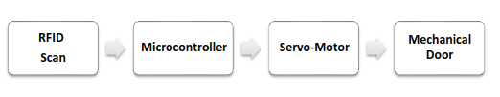

Image 1

Another working principle for the lock system is our smart phone. We created an application that will easily help us to open our door and to know our property safety with it. Anywhere you are it will notify you by using its WiFi module.

Important Components
Hardware:
1. Arduino U no
2. PWM Powered servo motor
3. 64 x 32 LCD display
4. RF-ID Reader, Card and Key
Software:
1.thinkr cad
2. Arduino IDE
Arduino UNO
Arduino is an open-source platform used for building electronics projects. Arduino consists of both a physical programmable circuit board (often referred to as a micro-controller) and a piece of software, or IDE (Integrated Development Environment) that runs on your computer, used to write and upload computer code to the physical board.
The Arduino platform has become quite popular with people just starting with electronics, and for good reason. Unlike most previous programmable circuit boards, the Arduino does not need a separate piece of hardware (called a programmer) to load new code onto the board -- you can simply use a USB cable. Additionally, the Arduino IDE uses a simplified version of C++, making it easier to learn to program. Finally, Arduino provides a standard form factor that breaks out the functions of the micro-controller into a more accessible package.

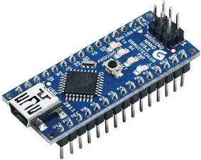

Image 2

PMW Servo Motor
A servo motor is a rotational or translational motor that receives power from a servo amplifier and is used to impart torque or force to a mechanical device like an actuator or a brake. Servo motors provide exact angular position, acceleration, and velocity control. A closed-loop control system is used with this type of motor. A closed-loop control system takes the current output into account and adjusts it to the desired state. The output
of the motor drives the control action in these systems. The velocity and final position of the shaft is controlled by a positive feedback mechanism.
In these motors, there are two forms of current flow: AC and DC. AC servo motors are more typically found in heavy industrial machines because they can sustain higher current surges. DC Servo Motors from ISL are best suited for compact applications and provide great control and feedback. The frequency of the applied voltage and the number of magnetic poles affect the speed of a servo motor.

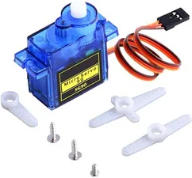

Image 3

64 x 32 Alphanumeric Display
An LCD (Liquid Crystal Display) screen is an electronic display module and has a wide range of applications. A 16x2 LCD is a very basic module and is very commonly used in various devices and circuits. A 64x32 LCD means it can display 64 characters per line and there are 32 such lines. In this LCD each character is displayed in a 5x7 pixel matrix. The 64 x 32 intelligent alphanumeric dot matrix display is capable of displaying 224 different characters and symbols. This LCD has two registers, namely, Command and Data. Registers.

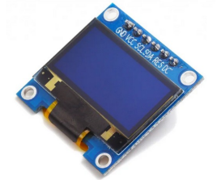
Image 4

RF-ID Reader
Radio Frequency Identification is a form of wireless communication that incorporates the use of electromagnetic or electrostatic coupling in the radio frequency portion of the electromagnetic spectrum to uniquely identify an object, animal or a person. Every RF-ID system consists of three components: a scanning antenna, a transceiver and a transponder. When the scanning antenna and transceiver are combined, they are referred to as an RF-ID reader or integrator. There are two types of RF-ID readers -fixed readers -mobile readers.
The RF-ID reader is a network connected device that can be portable or permanently attached. It uses radio waves to transmit signal that activate the tag.
The transponder is in the RF-ID tag itself. The read range for RF-ID tags varies based on factors including the type of tag, type of reader, RF-ID frequency and interference in the surrounding environment or from other RF-ID tags and readers. Tags that have a stronger power source also have a longer read range.
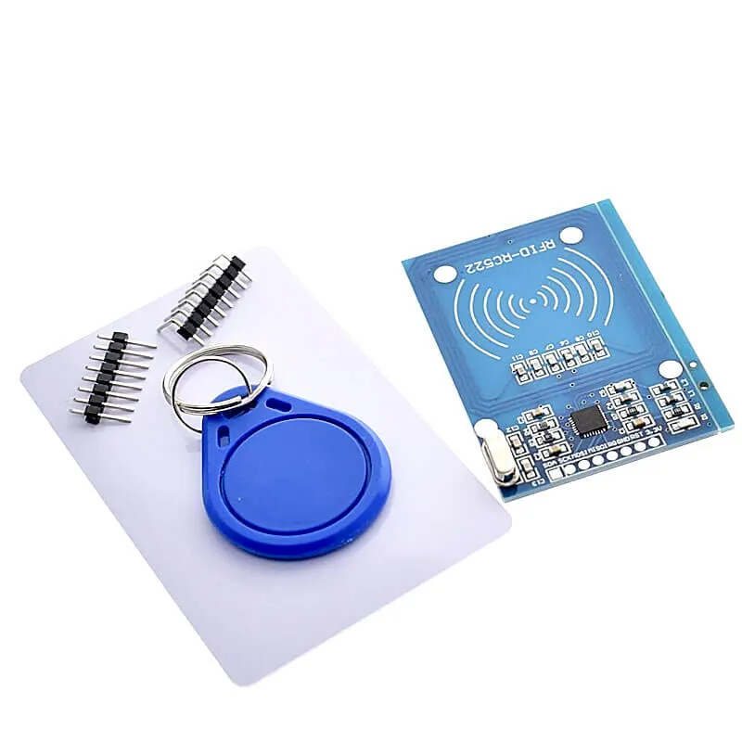

Image 5

ENGINEERING ANALYSIS

Electrical circuit design and implementation
At first , we will connect our bread-board to the Arduino that we showed in the above section. Then RFID will connect with the Arduino Na-no. We first scan the RFID card with the reader after that we will get code in Arduino IDE. So that code must be found in that same card otherwise if it is not the display will show as “wrong card”.
Then we connect the OLED display 0.96 to the Arduino board. This allowed us to view the inserted value and messages.

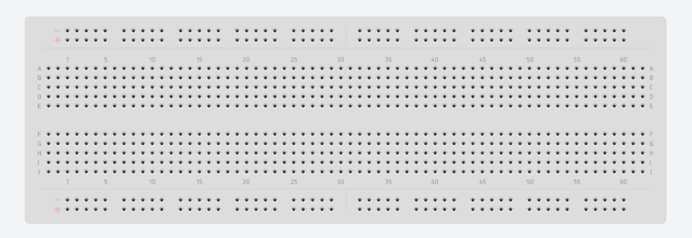

Image 6

As we can see on fig this is called breadboard. Its the place where we can connect circuits without soldering in-order to use it for many projects as much as we can.
First step will be connecting this with the Arduino.

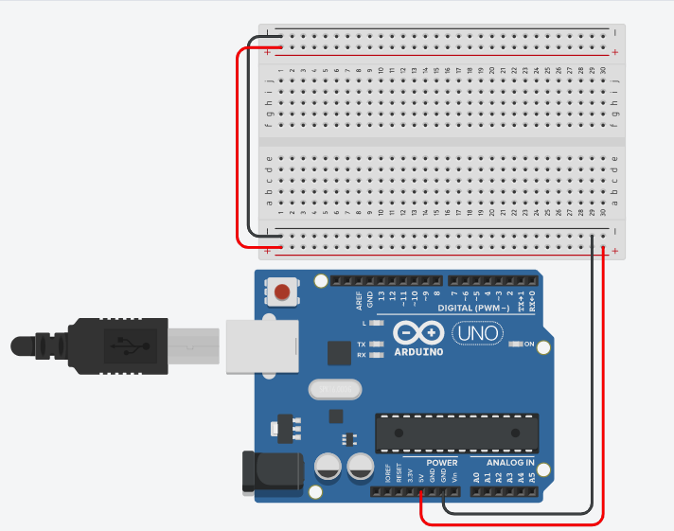

Image 7

second step includes servo motor.

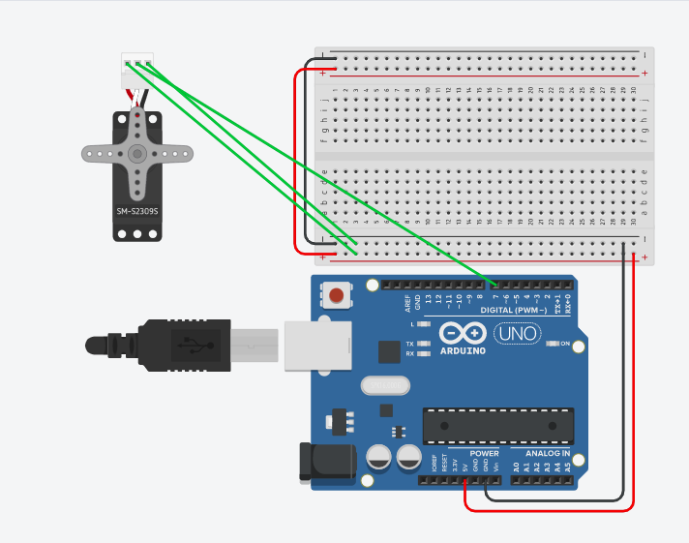

Image 8

as we can see on the second step we used micro-servo motor. It has three teeth.
- The first teeth is that connects with the ground (VSS).
- The second teeth is that connects with the digital row.
- The third will connect to the power (VCC).
This will enables us to control the position of the micro servo motor with PI and PID accurately.
Third step includes DHT-11.

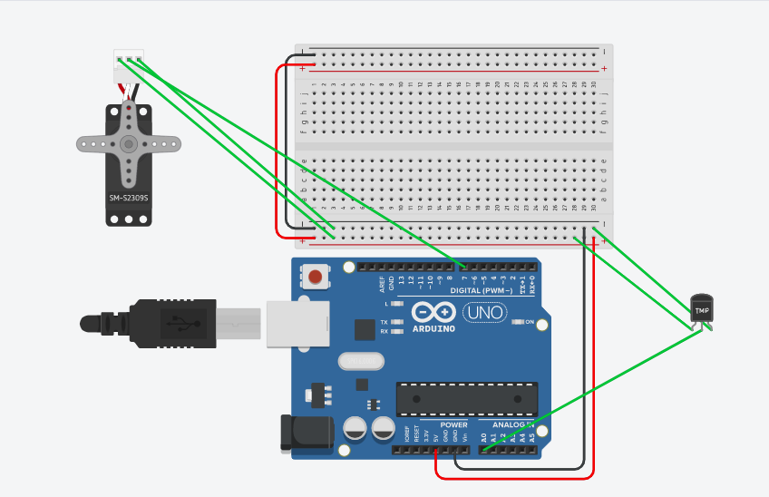

Image 9

This step is about connecting digital humidity and temperature sensor with the Arduino. This DHT will help us monitoring the humidity and temperature.
This also has three teeth.
- First teeth will connect to the ground (VSS).
- Second teeth will connect to A0 (analog).
- Third teeth will connect to the power supply (VCC).
This will help us to send information about the humidity and temperature to our phone for safety purpose.

Four step includes

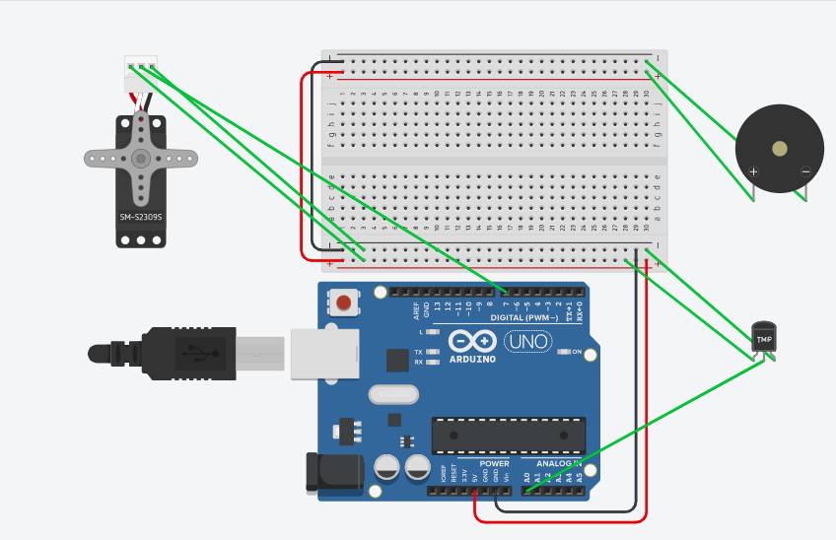

Image 10

the fourth step is all about the sound sensor. This will enables us to control the light bulb with a sound of the user or sound of hand clap.

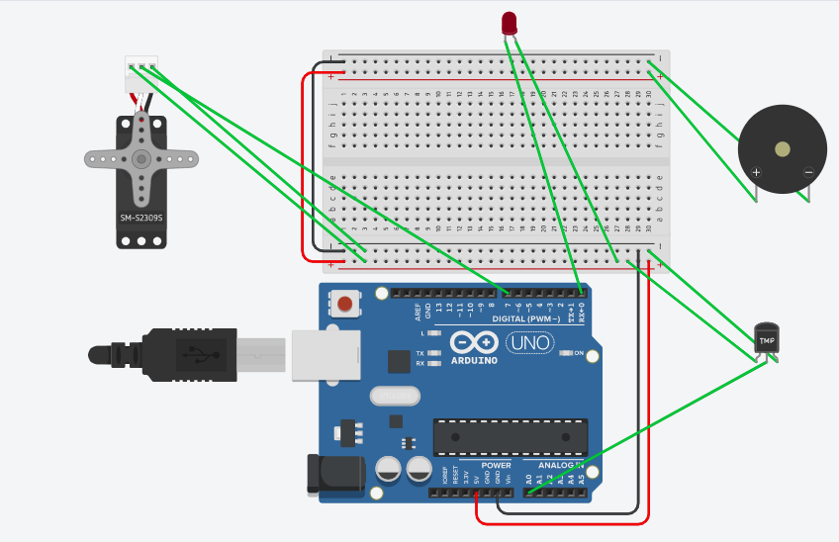

Image 11

As we can see here there's a LED. This will be maintained by two teethes. One teeth will connect to the digital while the other to the ground. The reason we connect the one teeth with digital is we don’t want the LED to light up normally we need to control it specifically with sound and our phone.
Fifth step includes ultrasonic sensor.

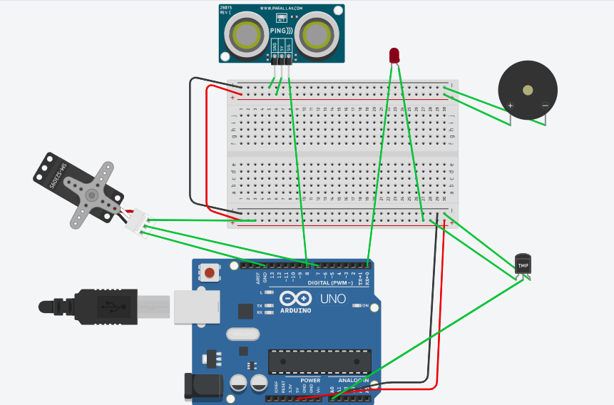

Image 12

this step focuses on the ultrasonic sensor. This sensor will be play a huge role in our project mainly for security purposes. It will have four teeth.
- One teeth will connect the ground (VSS).
- Second teeth will connect the Trigger Input (TRIG).
- Third teeth will connect with the Echo Input (ECHO).
- The last one with the power supply (VCC).
Distance = speed of sound in air * time / 2
this will help us to know how much distance our sound wave travel and get reflected.
So this all our electric circuits design with schematic view. This will define our project with a understandable plan.

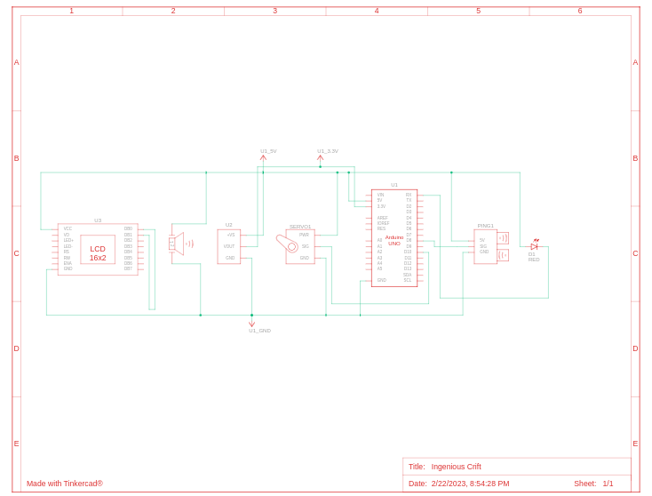

Image 13

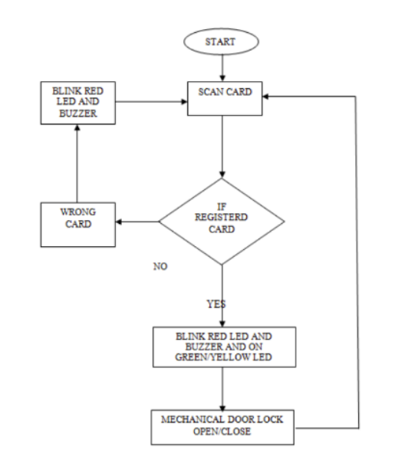
Image 14

Dorm Modeling
Dorm modeling is the process of creating a virtual model of a dormitory. This model can be used to simulate a variety of scenarios within the dormitory, such as assessing how much natural light will enter the room, where furniture should be placed, what kind of electrical outlets are needed, and how much noise will be generated within the space. With this information, designers and architects can adjust the dorm's design and make the best use of the space. Additionally, dorm modeling can help identify potential safety hazards and make the dorm more comfortable for inhabitants. As dorms become more and more popular around the world, dorm modeling is becoming more important.
Main steps to design a Dormitory
- Gather all the necessary materials needed to create the model, including a ruler, masking tape, modeling clay, tools, and paints.
- Measure and mark the walls, windows and doors to get an accurate layout of the room.
- Construct the basic frame of the dorm room on a foam board or other base. This should include outlining the walls, windows, furniture, and ceiling.
- Start adding detailing to the walls by constructing a wall material out of modeling clay, such as brick or stone.
- Paint the walls, furniture, and other decorations in the desired colors.
- Layout the furniture pieces inside the room and secure them in place with masking tape or pins.
- Add any desired accessories to the room, such as a desk, bed, decorations, and plants.
- Make any small adjustments as necessary to create the desired look for the room.
By following this step , we have to be able to create easily accessible , simple and cost-efficient dormitory.
Layout
Rooms :
- Beds
- Desk
- Chairs
- Closets
- Desks
we have to include all of the things that mentioned in the above section. We believe this will create a real simulation for our project.
Design
this part given to three department students.
- Bodana (Civil) – structure design
- Ezana (environmental) – identification of fabrics and materials
- Ibrahim (Electro-mechanical) – 3d modeling with Auto-cad
Final design
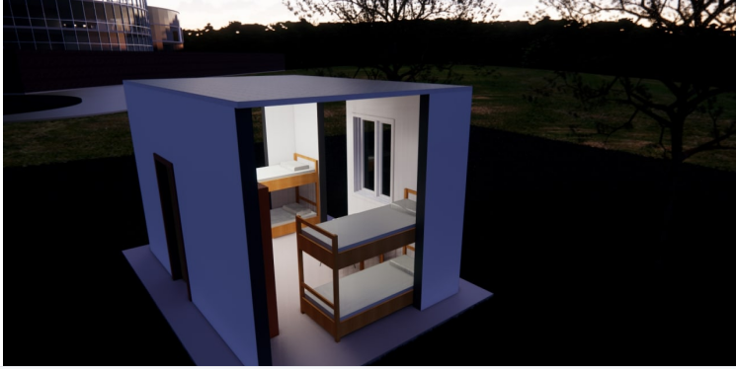
Image 15

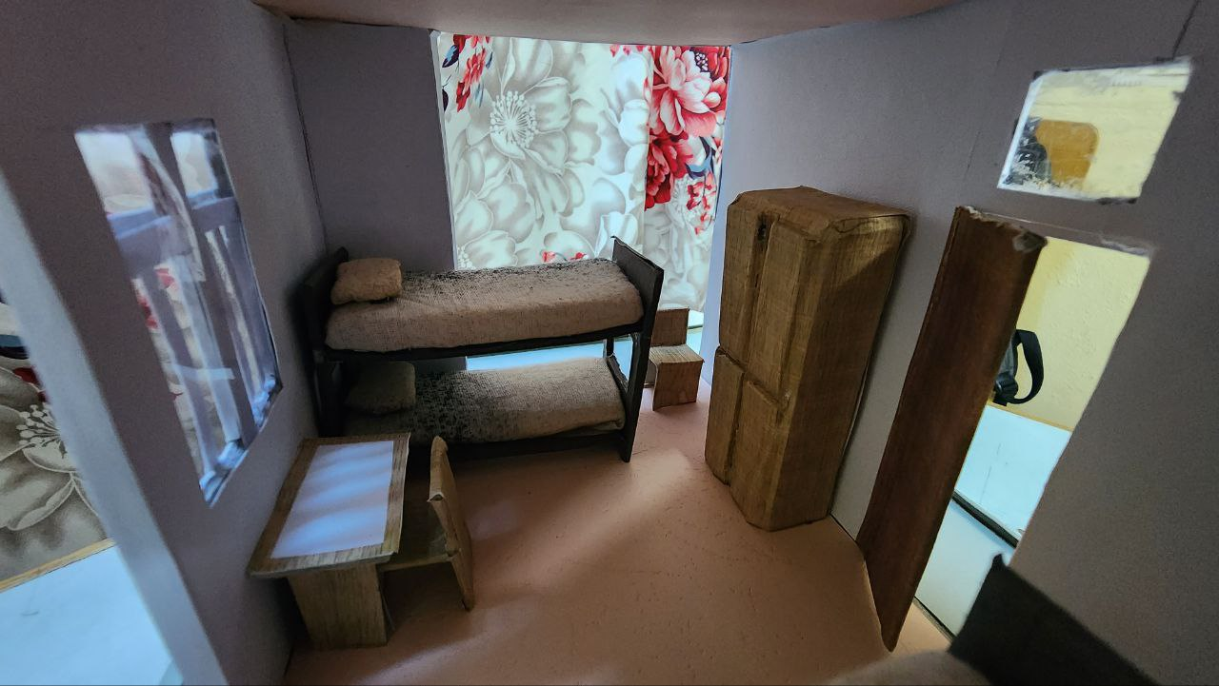

Image 16

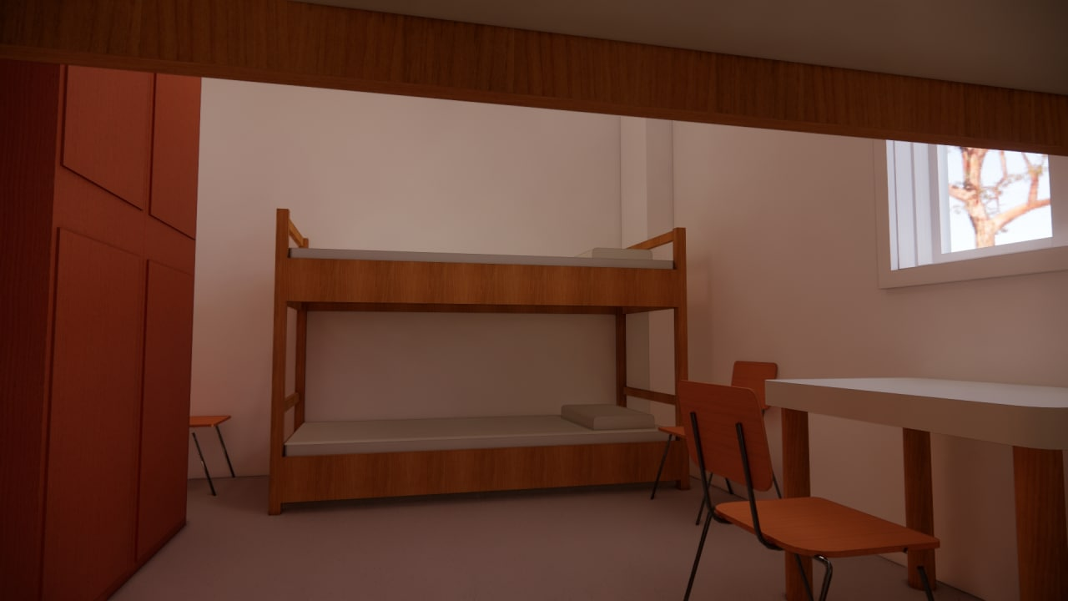

Image 17

The purpose of this report is to analyze the potential benefits of implementing dormitory models in institutions of higher learning. This report will outline the costs and benefits of such an implementation, taking into account the existing room designs and cost structures in the existing dormitory system. Additionally, the report will analyze how streamlined, dormitory models can enable students to maximize their academic success, improve the overall campus atmosphere, and help institutions to save on resources.
The concept of dormitory modeling is not a new one; it has been implemented in various educational settings around the world. In many cases, installation of dormitory models has been found to improve the overall student experience, regardless of their background, living situation, or academic program. Implementing this model could also offer institutions savings in the long run, by reducing the amount of staff and resources used for managing traditional dormitories.

PROJECT PLANNING
This step mainly focuses on task allocation between members of group 94. as we can see on the table there are roles that each members play. This will help us to run the project flawlessly along with time and energy efficiency.

Table 1
No | Name | Procurement Role
1 | Dagmawi Esayas | Arduino coding & installation
2 | Fatima Abayneh | Coding and E-portfolio management
3 | Ibrahim Kedir | Model designing and control interaction b/n model & electric
4 | Bodana Fikiru | Construction of the designed model & maintenance
5 | Ezana Dagmawi | Leader of group 94 and assist by selecting less cost material
6 | Yordanos Getachew | Installation of electric circuit design

There will be a gantt chart also. This also contributes in making the project starts and ends with no flaws whatsoever. Beside that it will help us to be aware of the time we have got to finish our project in order to be punctual we must implement our own given gantt chart.

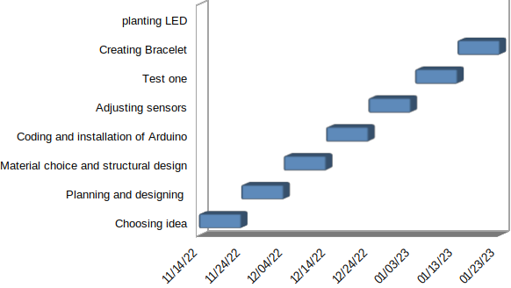

Figure 1

RESULT & ANALYSIS
It is an IoT-based gadget designed for RF ID-based door locking systems, developed with the help of Arduino. This gadget is being managed by software programming. Let us see how this door lock system works. A 12-volt power adapter is used for the power supply and can also use a 9-volt battery instead of a power adapter. As can see on the screen, it is displaying welcome to my home, if scan any card which is unregistered it shows the wrong card, and the lock is locked. If scanning the registered card, it opens the door lock. And now scan the registered card again, the lock is locked.
One of the biggest improvements over earlier tested locks was the improved security of the RFID tags. Several of previous tested locks proved that the RFID tags could be cloned, duplicated and used to open the lock without user knowledge. To be fair, this could also be done to a physical key for a regular deadbolt lock, but it would be significantly harder to perform successfully by copying a key. An RFID key tag could be read and copied in around 10 seconds, allowing for an adversary to perform such an attack while a user is simply distracted with something else for a short period of time.
Hence, in a security perspective it is very welcome that the manufacturer has chosen to improve on the security when it comes to RFID cloning, which now is not possible due to a higher encryption standard. By using AES which is de-fact standard for private key encryption and considered unhackable and secure by the Cyber security community, the manufacturer has proven to ad- dress previous security issues with a satisfying result.
One could argue that the RFID tags could be hacked if the private key was somehow leaked, which even if possible, is highly unlikely since it is stored locally on the lock and the key tag and hence not distributed via insecure channels of communication.

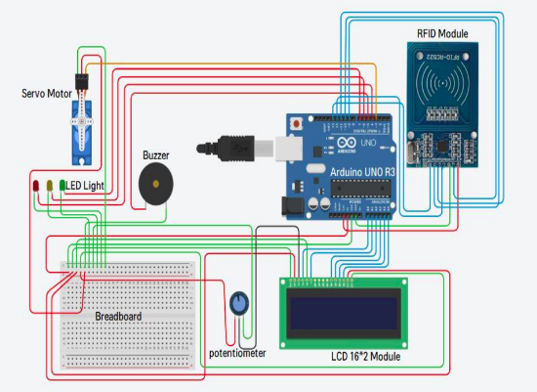

Image 18

BUSINESS & ECONOMIC ANALYSIS
Before we talk about the business analysis of smart dorm system we have to look the cost table then we will begin analyzing which why how is our smart dorm better than other financially.

Table 2
S. No | Material | Specification | Quantity | Cost
1 | Arduino Na-no |  | 2 | 2000
2 | RFID Reader |  | 1 | 500
3 | RFID Card & key |  | 1 | 300
4 | Temperature & Humidity Sensor |  | 1 | 200
5 | Servo Motor |  | 1 | 400
6 | Jumper wires |  | 1 | 100
7 | Sound Sensor |  | 1 | 100
8 | Ultrasonic sensor |  | 1 | 500
9 | RGB & LED |  | 9 | 300
10 | Resistors |  | 20 | 100
11 | Solder wire |  | 1 | 400
12 | Battery |  | 1 | 200
13 | Relay |  | 1 | 500
14 | Buttons |  | 4 | 200
15 | Battery plug |  | 1 | 100
16 | WIFI module |  | 1 | 500
17 | OLED Display |  | 1 | 1000
18 | Transistors |  | 6 | 240
19 | Dorm Room Model |  | 1 | 800
 | Grand Total |  | 55 Items | 8,440Br.

Smart RFID locks are a type of access control system that uses radio frequency identification (RFID) technology to provide secure access to a building or area. They are becoming increasingly popular in commercial and residential settings, as they offer a convenient and secure way to control access.

11.1. Business Analysis:
The smart RFID lock market is growing rapidly due to the increasing demand for security solutions in both commercial and residential settings. The market is expected to reach $3.5 billion by 2026, with an estimated compound annual growth rate of 10%. This growth is driven by the increasing adoption of smart home technologies, the need for improved security measures, and the convenience offered by RFID locks.
The major players in the smart RFID lock market are Honeywell International Inc., ASSA ABLOY AB, Allegion plc, dormakaba Holding AG, and Salto Systems S.L., among others. These companies offer a wide range of products and services related to access control systems, including smart RFID locks.

11.2. Economic Analysis:
The economic impact of smart RFID locks is significant. They provide businesses with increased security measures that can help reduce losses due to theft or unauthorized access. Additionally, they can help improve efficiency by allowing employees to quickly enter and exit buildings without having to manually open doors or use keys. This can lead to cost savings in terms of time and labor costs associated with manual door opening processes.
Smart RFID locks also have a positive impact on the environment as they reduce energy consumption associated with traditional door opening methods such as keypads or mechanical keys. Furthermore, they can help reduce waste associated with lost keys or forgotten passwords as users no longer need physical keys or passwords to gain access.

CONCLUSION
The Internet of things is one of the revolutionary achievements in the field of technology. It is a concept that defines the idea of making the everyday physical object digitalize by connecting with the internet. Similarly, this project is also connecting the door lock with the internet to develop a smart door locking system. Likewise, the main aim of this project is to design a smart door lock having RFID and Bluetooth technology, and the smartphone application as a controlling mechanism has been developed successfully. The objective of the smartphone application to connect the door lock with the internet is successfully achieved at the end.
This project is an affordable design of smart lock that enhance the security of the houses. This design is comparatively small and easy to install with just a pair of screws. Similarly, this door lock device is advanced and secure than any other traditional locks. Moreover, this type of door lock is not only for the house door, but also it can be great in use for hotels, motels, hospitals, and other commercial buildings for access control and safe. It can even be used in the car door too. Moreover, this lock can be a simple and cost-effective upgrade to the average consumer’s security.
Thus “Smart Door Locking System using Arduino” is a modern successor of the conventional door locking system. The conclusion of the discussion of smart Lock using Arduino is the innovation created from the lock system with no more direct contact between the user and the lock. This system is very cost-effective and easy to install. In conclusion, it was discovered that the project performed according to specification and can be implemented. The use of the Arduino UNO micro-controller in this project allows for design simplicity, hence, the project can be achieved in lesser time compared to other techniques previously employed. This work proposes a secure locking/unlocking system based on a keypad and Arduino. Adding password to the Arduino side increase the system security. The system also has a feature for locking itself after some delayed time.

RECOMENDATION
We recommend a lot of things to be used in the next part of our project.
- Raspberry pi

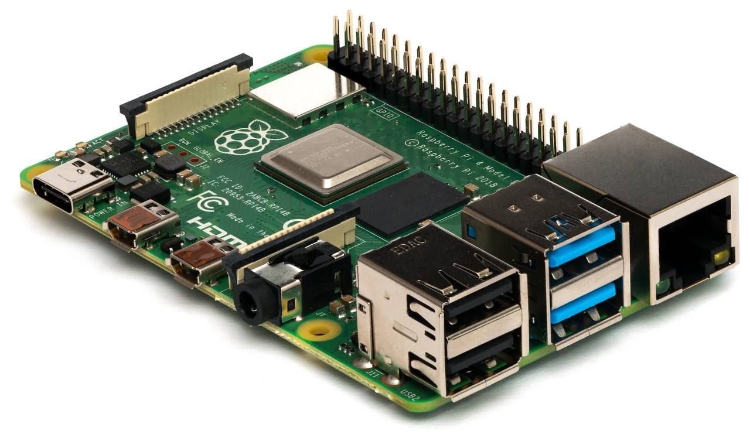

Image 19

- DHT-22
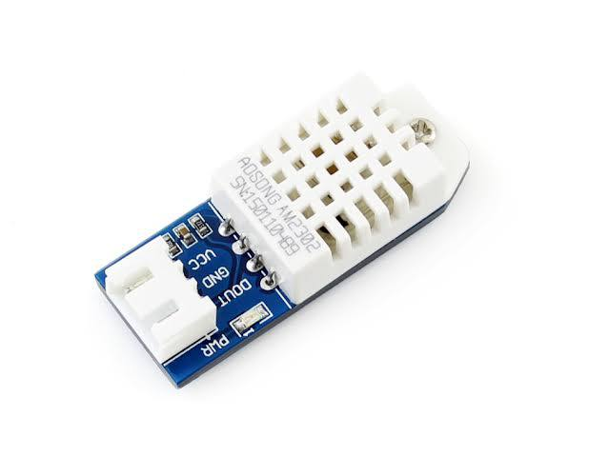

Image 20

- solenoids locking
- cameras
- transparent model
- DSS-M15S metal servo with analog feedback
- better back-end applications
- HY-SRF05 ultrasonic sensor
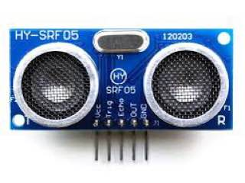
Image 21

By using this material we can create the best smart dorm system with out no difficulties.

REFERENCE
- Orji EZ, Oleka CV, Nduanya UI, Automatic Access Control System
using Arduino and RFID, Journal of Scientific and Engineering

- Zeydin Pala and Nihat Inan, “Smart parking application using RFID
technology”, RFID Eurasia, 1st Annual in RFID Eurasia, 2007.

- Dejan Nedelkovski, (2017), "How RFID Works and How To Make an
Arduino based RFID Door Lock” Arduino Tutorials – How To
Mechatronics", Retrieved 29 May 2021, from
http://howtomechatronics.com/tutorials/arduino/rfid-works-make-
arduino-based-rfid-door-lock.

- Xiao, Y., Yu, S., Wu, K., Ni, Q., Janecek., C., Nordstad, J,” Radio
frequency identification: technologies, applications, and research
issues” Wiley Journal of Wireless Communications and Mobile
Computing, Vol 7, May 2007

- Website Reference: https://www.arduino.cc
- Ramalatha, M., Ramkumar, A. K., Selvaraj, S. and Suriyakanth, S,
(2014), “RFID Based Personal Medical Data card for Toll
Automation”. Elysium Journal Engineering Research and
Management. Volume1, ISSN: 2347-4408, pp 51-52.

- Umar Farooq, Mahmood ul Hasan, Muhammad Amar, Athar Hanif,
and Muhammad Usman Asad, (2014), "RFID Based Security and
Access Control System" IACSIT International Journal of Engineering
and Technology, Vol. 6, No. 4, August 2014

